PRE-FLIGHT INSPECTION

COCKPIT PREPERATIONS

1 | All chocks,tiedowns and pitot cover removed | CHECK
2 | Parking brake / Brakes | CHECK FREE MOVEMENT,  PRESSURE & FLUID LEVEL – SET ON
3 | Fire extinguisher & First aid kit | CHECK
4 | Aircraft documents | CHECK
5 | Magneto switches | OFF – KEY OUT
6 | Avionics master switch | OFF
7 | Fuel shutoff valve | ON
8 | Main fuses | PUSH IN
9 | Master switch | ON
10 | Anti – collision lights & Landing lights | CHECK & OFF
11 | Electric fuel pump | CHECK & OFF
12 | Master switch | OFF
13 | Seatbelts & shoulder harnesses | CHECK CONDITION &  SECURITY
14 | Aileron cable mounting & rod ends | CHECK FOR FREE ROTATION & EXCESSIVE MOVEMENT, BOLTS & ANCHORS ON REAR OF SEATS SECURE.
15 | Elevator cable mounting & rod end | CHECK FOR FREE ROTATION & EXCESSIVE MOVEMENT, BOLT & ANCHOR ON MAIN BEAM SECURE.
16 | Throttle | CHECK MOVEMENT & MOUNTING.
17 | Rudder & nose wheel steering pushrods & ends | CHECK SECURITY & FREE MOVEMENT.
18 | Flaps | SET FIRST STAGE. CHECK FOR FREE MOVEMENT, EXCESSIVE PLAY & BOLT SECURE. CHECK ROD ENDS / CONTROL LINKAGE FOR EASE OF ROTATION.
19 | Trimmer | EXCERSISE – SET NEUTRAL
20 | Fuel Contents | CHECK

1

EXTERNAL CHECKS
1 | Port undercarriage | CHECK MAIN LEG SECURITY & BOLTS, SPEED FAIRING SECURITY,  WHEELS & BRAKES, HYDRAULIC LINES, TYRE INFLATION, CREEP MARKS AND CONDITION.
2 | Port wing strut | CHECK LOWER AND UPPER ATTACHMENTS (BOLTS MUST NOT BE TIGHT) GENERAL CONDITION OF STRUT. SECURITY OF UPPER SPEED FAIRING.
3 | Port wing – Root mount bolts | CHECK BOLT SECURITY. CHECK LOWER COVER FAIRING & TOP COVER STRIP SECURITY.
4 | Port wing – Flap | CHECK SECURITY. CHECK HINGE SECURITY & LUBRICATION. CHECK ROD ENDS FOR EASE OF ROTATION/EXCESSIVE MOVEMENT & BOLT SECURITY.
5 | Port wing – Trailing Edge | CHECK AILERON FREEDOM OF MOVEMENT/SECURITY. HINGES LUBRICATED, PINS SECURE. CHECK AILERON CABLE ROD END FOR EASE OF ROTATION/EXCESSIVE MOVEMENT/BOLT SECURE.
6 | Port wing – Tip | CHECK FOR DAMAGE, LIFT TIP TO CHECK STRUT/WING SECURITY & ROCK FORE – AFT TO CHECK UNDERCARRIAGE LEG SECURITY.
7 | Port wing – Aileron attachment | CHECK THROUGH INSPECTION WINDOW FOR CABLE SECURITY.
8 | Port Wing – Leading edge | CHECK STALL WARNING APATURE CLEAR OF OBSTRUCTIONS AND TEST OPERATION BY CAREFUL SUCTION. CHECK LEADING EDGE FOR DAMAGE.
9 | Port door & window | SECURE & UNDAMAGED. LATCHES & HINGES SECURE AND OPERATIONAL.
10 | Windscreen | CLEAN & UNDAMAGED
11 | Port Nose | VENTS CLEAR. LOWER COWL SECURE.
12 | Nose Leg | CHECK SECURITY. CHECK WHEEL SECURITY/AXLE NUT. TYRE INFLATION, CONDITION & CREEP MARKS. SUSPENSION RUBBERS.
13 | Propeller & Spinner | CHECK CONDITION & SECURITY
14 | Remove Top Cowl (Daily inspection) | CHECK SECURITY OF ENGINE MOUNTS, ENGINE COMPONENTS & SYSTEMS, SPARK PLUGS, WIRING, FUEL LINES, BAFFLES ETC. LOOK FOR OIL LEAKS. CHECK OIL LEVEL/TOP UP IF NECESSERY.  CHECK BATTERY FLUID LEVEL.  CHECK OIL OVERFLOW BOTTLE LEVEL.
15 | Replace Top Cowl | ENSURE FRONT LUGS ARE ENGAGED AND MAIN CLIPS SEATED AND PINNED CORRECTLY. CHECK FOR ALIGNMENT OF RAM AIR DUCTS AND SEALS.
16 | Starboard nose | VENTS CLEAR. LOWER COWL SECURE.
17 | Starboard door & window | SECURE & UNDAMAGED. LATCHES & HINGES SECURE AND OPERATIONAL.
18 | Starboard undercarriage | CHECK MAIN LEG SECURITY & BOLTS, SPEED FAIRING SECURITY,  WHEELS & BRAKES, HYDRAULIC LINES, TYRE INFLATION, CREEP MARKS AND CONDITION.
2

19 | Starboard wing strut | CHECK LOWER AND UPPER ATTACHMENTS (BOLTS MUST NOT BE TIGHT) GENERAL CONDITION OF STRUT. SECURITY OF UPPER SPEED FAIRING.
20 | Starboard wing – Root mount  bolts | CHECK BOLT SECURITY. CHECK LOWER COVER FAIRING & TOP COVER STRIP SECURITY.
21 | Starboard wing – Leading edge | CHECK LEADING EDGE FOR DAMAGE.
22 | Starboard wing – Tip | CHECK FOR DAMAGE, LIFT TIP TO CHECK STRUT/WING SECURITY & ROCK FORE – AFT TO CHECK UNDERCARRIAGE LEG SECURITY.
23 | Starboard wing –  Aileron attachment | CHECK THROUGH INSPECTION WINDOW FOR CABLE SECURITY.
24 | Starboard wing – Trailing Edge | CHECK AILERON FREEDOM OF MOVEMENT/SECURITY. HINGES LUBRICATED, PINS SECURE. CHECK AILERON CABLE ROD END FOR EASE OF ROTATION/EXCESSIVE MOVEMENT/BOLT SECURE.
25 | Starboard wing - Flap | CHECK SECURITY. CHECK HINGE SECURITY & LUBRICATION. CHECK ROD ENDS FOR EASE OF  ROTATION/EXCESSIVE MOVEMENT & BOLT SECURITY.
26 | Transponder antenna | CONDITION & SECURITY
27 | Fuel drain | SAMPLE CHECK FOR WATER/CONTAMINANTS.
28 | Fuselage drain holes | CHECK CLEAR
29 | Rear window | UNDAMAGED & CLEAN
30 | Starboard side ventral fin | SECURE. CHECK DRAIN HOLE & TIE DOWN EYE SECURITY.
31 | Starboard tailplane | CONDITION & SECURITY
32 | Tail fin | CONDITION & SECURITY
33 | Static source | CHECK CLEAR
34 | Elevator | CONDITION/HINGES SECURE AND LUBRICATED. HINGE PINS SECURE. TRIM TABS SECURE. FULL & FREE MOVEMENT.
35 | Rudder | CONDITION/HINGES SECURE & LUBRICATED. HINGE PINS SECURE. FULL & FREE MOVEMENT (WITH NOSEWHEEL OFF THE GROUND) CHECK CABLE ROD END FOR EASE OF ROTATION/EXCESSIVE MOVEMENT. BOLT SECURE.
36 | Strobe lamps | CONDITION & SECURITY
37 | Port tailplane | CONDITION & SECURITY
38 | Port side ventral fin | CONDITION & SECURITY
39 | Fuel filler cap | SECURITY
40 | Port side rear window | UNDAMAGED & CLEAN
41 | Flaps | UP

3

INTERNAL CHECKS

1 | External checks | COMPLETE
2 | Flaps | UP
3 | Doors | CLOSED & SECURE
4 | Harnesses | ADJUSTED & SECURED
5 | Baggage | SECURE
6 | Brakes | PARK POSITION
7 | Fuel shut off valve | CHECK ON
8 | Flying controls | FULL & FREE MOVEMENT
9 | Instruments & Gauges | CHECK
10 | Trim | EXERSIZE – SET TAKE OFF
11 | Throttle | EXERSIZE – SET CLOSED
12 | Carb heat | EXERSIZE – SET COLD
13 | Magnetos | CHECK – OFF
14 | Avionics Master | CHECK – OFF

STARTING ENGINE
1 | Master Fuses | PUSH IN
2 | Circuit Breakers | CHECK - ON
3 | Master Switch | ON
4 | Strobes | ON
5 | MAGNETO’S | CHECK OFF
6 | Fuel Pump | ON
7 | Choke | FULL ON
8 | Pull Prop though 6 times | PRIME ENGINE FUEL
9 | Fuel Pump | OFF
10 | Throttle | CHECK - CLOSED
11 | LOOKOUT | GOOD LOOK AROUND.  SHOUT ‘CLEAR PROP’
12 | Magnetos | KEY IN – OPERATE STARTER
13 | Throttle | SET IDLE 1000 –1200 RPM
14 | Oil Pressure | CHECK RISING (SHUT DOWN  IF NO RISE IN 10 SEC)
15 | Starter Motor Warning Light | CHECK OUT
16 | Choke | CLOSE GRADUALLY.  MAINTAIN ENGINE IDLE SPEED
17 | Warm – up engine | 1200RPM UNTIL 50 DEG C.
18 | Instrument T’s & P’s | CHECK ALL
19 | Avionics | MASTER ON – RADIO ETC ON.

4

TAXI-ING CHECKS
1 | Radio | CHECK READABILITY
2 | Obtain Taxi clearance | ATC
3 | Altimeter | SET
4 | Brakes | CHECK
5 | Rudder / Nosewheel | CHECK FULL MOVEMENT
6 | Turn & Slip / Compass / DI | CHECK IN TURNS

POWER CHECKS
1 | Temperature | CHECK 50 DEG C.
2 | Fuel | CHECK ON / CONTENTS
3 | Temperatures & Pressures | CHECK
4 | Check clear behind | SET 2000rpm HOLD 10 sec.
5 | Check Magnetos | DROP NOT TO EXCEED 100rpm
6 | Carb Heat | CHECK RPM DROP / TEMP INCREASE.
7 | Alternator Load | WITHIN LIMITS
8 | Slow Running | CHECK IDLE
9 | Set throttle | 900-1200rpm
10 | Carb heat | APPLY FOR 30 sec.

PRE TAKE-OFF CHECKS
1 | Flaps | SET 1ST STAGE
2 | Trimmer | SET TAKE-OFF
3 | Fuel | PUMP ON
4 | Carb Heat | CHECK – OFF
5 | DI / Compass | ALIGHNED
6 | Magnetos | BOTH ON
7 | Gyros & Instruments | CHECK
8 | Doors / Harnesses | CHECK LOCKED
9 | Flight Controls | FULL & FREE
10 | Cylinder Head Temperatures | CHECK 100 DEG C. BEFORE  OPERATING FULL THROTTLE

5

TAKE OFF
1 | Flaps | 1ST STAGE
2 | Carb Heat | CHECK – OFF
3 | Throttle | FULL OPEN
4 | Elevator Control | LIFT NOSE WHEEL AT 40-45 KIAS  WAIT FOR AIRCRAFT TO FLY ITSELF OFF AT APPROX. 55 KIAS
5 | Climb Speed / Flaps | 65 KIAS UNTIL FLAPS RETACTED  AT 300FT. THEN CLIMB AT  72 KIAS.
6 | CHT’S | CHECK (100 – 200 DEG C.)
7 | Fuel Pump | OFF AT TOP OF CLIMB
8 | Brakes | APPLY THEN OFF TO STOP WHEELS SPINNING.

ENROUTE CHECKS (IFREDAC)
I | Icing | NONE PRESENT ON AIRFRAME.  CARB HEAT - ON.
F | Fuel | CONTENTS SUFFICIENT
R | Radio | CORRECT FREQUENCY SET
E | Engine | CHT’s, OIL PRES. TEMP. ETC.
D | D/I | ALIGHN WITH COMPASS
A | Altimeter | CORRECT SETTING
C | Carb Heat | CARB HEAT – OFF.

DOWNWIND CHECKS (CABFLICH)
C | Carb Heat | ON
A | Altimeter | SET AIRFIELD QFE
B | Brakes | CHECK – OFF
F | Fuel | PUMP ON
L | Landing lights | ON
I | Instruments | T’s & P’s. D/I & COMPASS
C | Carb Heat | AS REQUIRED. OFF ON SHORT FINAL.
H | Harnesses & Hatches | SECURE

6

LANDING
1 | Reduce speed | 70 KIAS MAX
2 | Flaps | FULL FLAPS
3 | Carb Heat | OFF (SHORT FINAL)
4 | Approach Speed | 55 – 57 KIAS

AFTER LANDING
1 | Flaps | UP
2 | Fuel Pump | OFF
3 | Carb Heat | OFF

SHUTTING DOWN
1 | Brakes | SET PARK
2 | Magnetos | CHECK BOTH
3 | Radio / Transponder / GPS | OFF
4 | Landing Lights | OFF
5 | Magnetos | OFF
6 | Key | OUT
7 | Strobes | OFF
8 | Avionics Master | OFF
9 | Master | OFF
10 | Main Fuses | PULL OUT
11 | Control Locks | IF REQUIRED
12 | Tie downs & Cover | IF REQUIRED

STALL CLEAN | 47 KIAS
STALL FULL FLAPS | 43 KIAS
BEST GLIDE | 72 KIAS
ENGINE FALIURE AFTER TAKE OFF | 60-65 KIAS
APPROACH SPEED NORMAL (WITH FULL FLAPS) | 57 KIAS
APPROACH SPEED – SHORT FIELD | 55 KIAS
APPROACH SPEED (CLEAN) | 70 KIAS
BEST MANOUVERING | 91 KIAS
V – SPEEDS

7

G-**** : JABIRU 450 SPL
SERIAL NUMBER: PFA ****-****

CHECKLIST

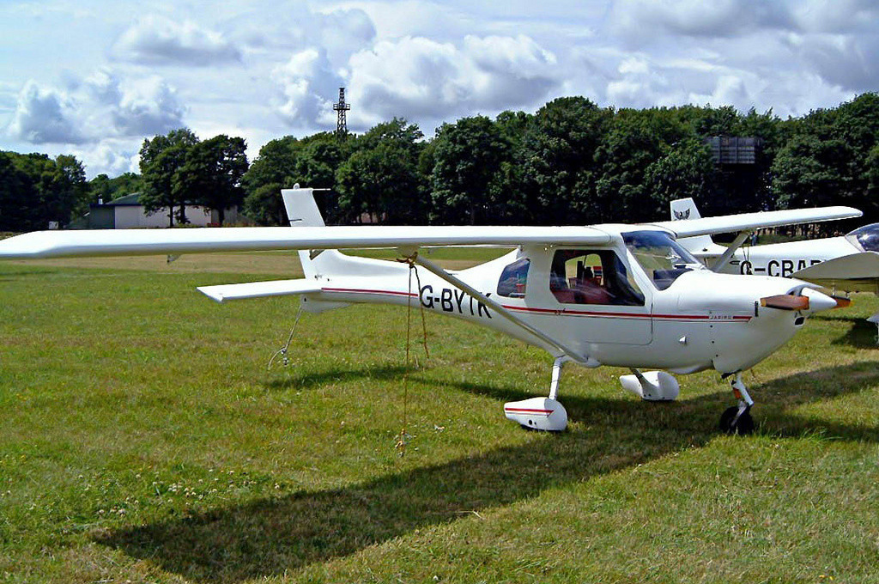

EMPTY WEIGHT  kgs | PILOT  kgs | PASSENGER |  | SUB TOTAL  kgs | FUEL  ltrs | FUEL WEIGHT  kgs | TOTAL  kgs
EMPTY WEIGHT  kgs | PILOT  kgs | St. | Kgs
268.00 | 81.00 | 11 | 70.0 | 419.0 | 43 | 31.0 | 450
268.00 | 81.00 | 12 | 76.4 | 425.4 | 34 | 25.0 | 450
268.00 | 81.00 | 13 | 82.8 | 431.8 | 25 | 18.0 | 450
268.00 | 81.00 | 14 | 89.1 | 438.1 | 17 | 12.0 | 450
268.00 | 81.00 | 15 | 95.5 | 444.5 | 8 | 6.0 | 450
268.00 | 81.00 | 16 | 101.8 | 450.8 | 0 | 0 | 450
268.00 | 81.00 | 16 | 101.8 | 450.8 | 15 | 10.8 | 461
268.00 | 81.00 | 17 | 108.1 | 457.1 | 15 | 10.8 | 468
268.00 | 81.00 | 18 | 114.5 | 463.5 | 15 | 10.8 | 475
268.00 | 81.00 | 19 | 121.0 | 470.0 | 15 | 10.8 | 481
268.00 | 81.00 | 20 | 127.0 | 476.0 | 15 | 10.8 | 489

